PALLEPOGU PRIESTLY

Uppalapadu , Guntur district

Andhra Pradesh located in

Pedakakani mandal of Guntur revenue division.

01-07-2023

31-08-2023

8 Weeks

20BQ1A4241

Vasireddy Venkatadri Institute of Technology

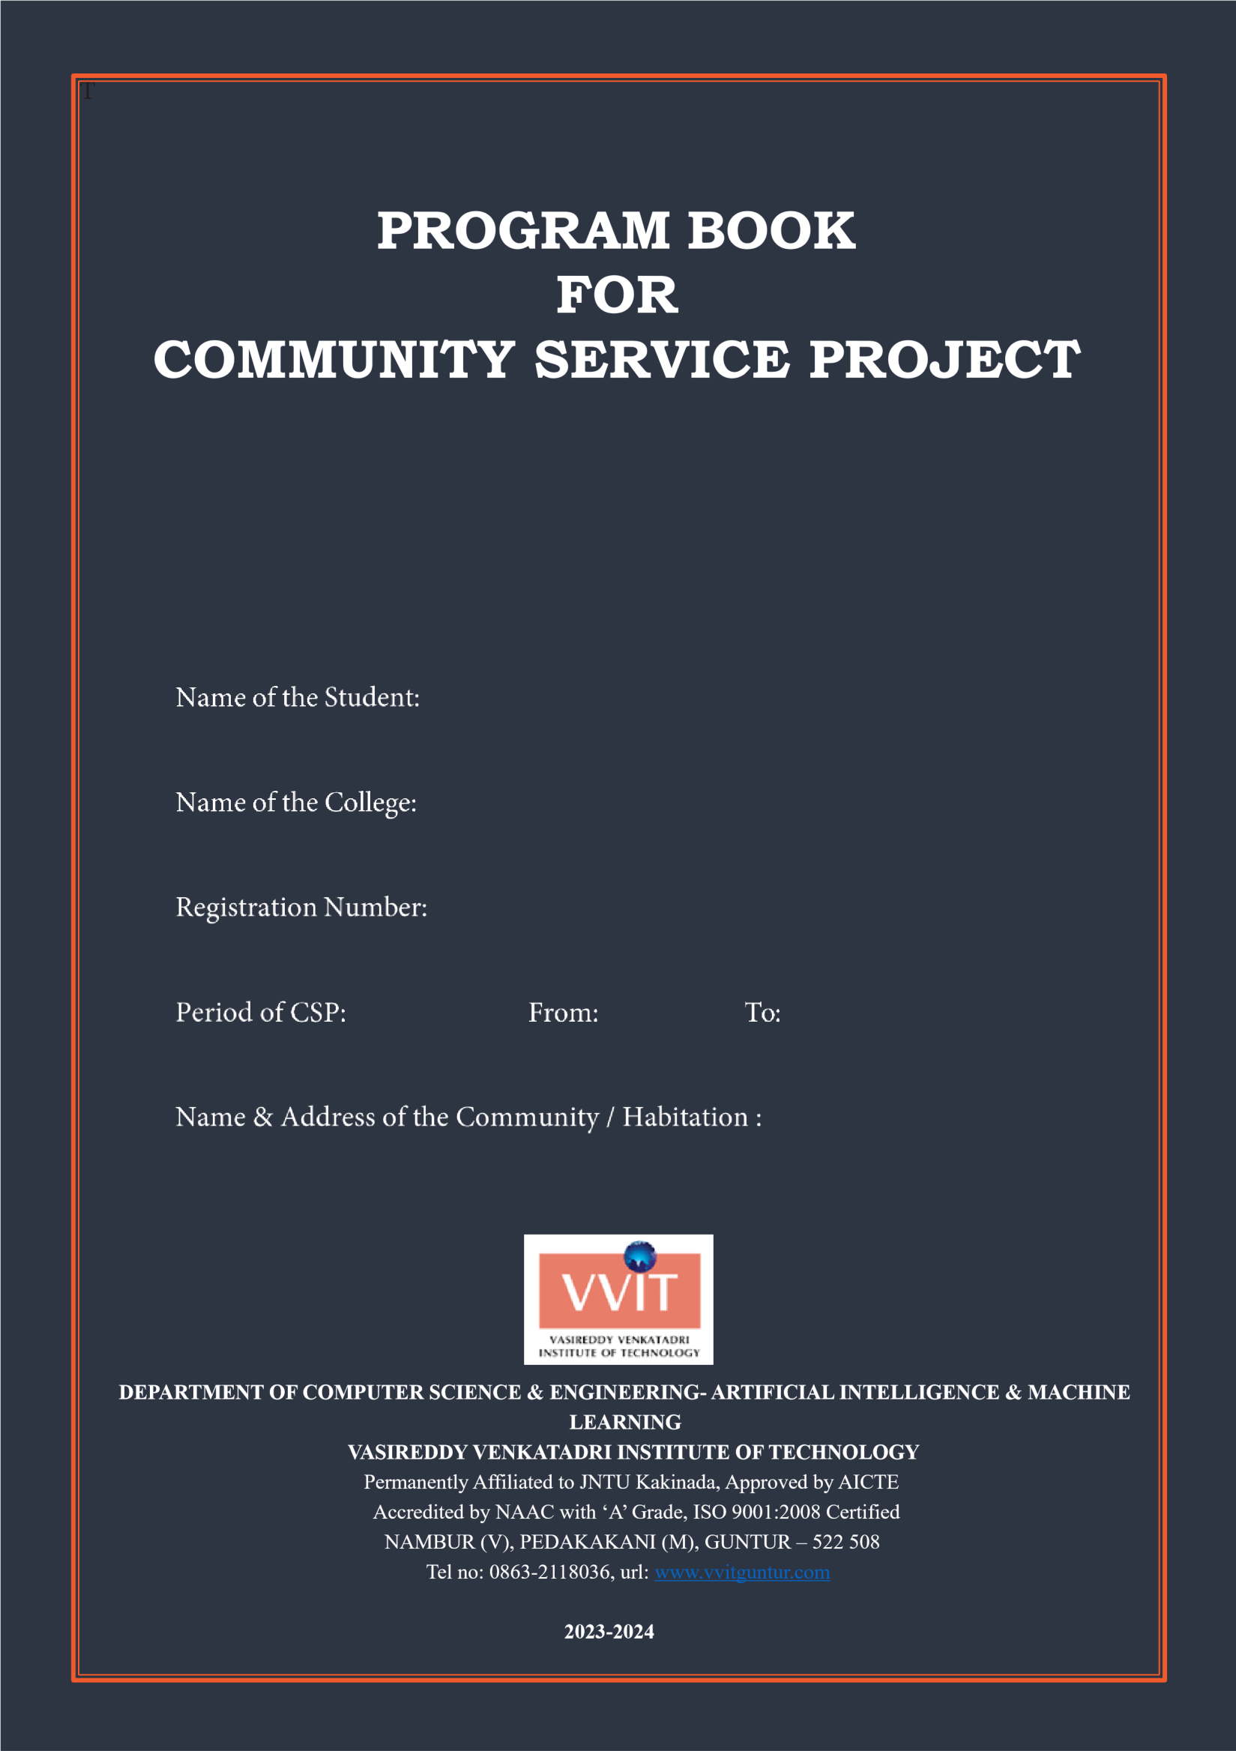

# Community Service Project Report

*Submitted in accordance with the requirement for the degree of Bachelor of Technology*

Name of the College : Vasireddy Venkatadri Institute of Technology

Department : COMPUTER SCIENCE ENGINEERING - ARTIFICIAL INTELLIGENCE & MACHINE LEARNING

Name of the Faculty Guide : Mr. S L V V D Sarma

Duration of the CSP : 8 Weeks From: 01-07-2023 To: 31-08-2023

Name of the Student : Pallepogu Priestly

Programmer of Study : B. Tech

Year of Study : IV -II

Register Number : 20BQ1A4241

Date of Submission : 26-03-2024

# Student’s Declaration

I, Mr. Pallepogu Priestly a student of Community Service Program, Reg. No, 20BQ1A4241

of the Department of Computer Science Engineering - Artificial Intelligence and Machine

Learning, Vasireddy Venkatadri Institute of Technology do hereby declare that I have completed

the mandatory community service from 01/07/2023 to 31/08/2023 in Uppalapadu, Guntur district

under the Faculty Guideship of Mr. S L V V D Sarma, Department of Computer Science

Engineering – Artificial Intelligence & Machine Learning in College.

***(Signature and Date)***

**Endorsements**

*Faculty Guide*

*Head of the Department*

*Principal*

**Certificate from Official of the Community**

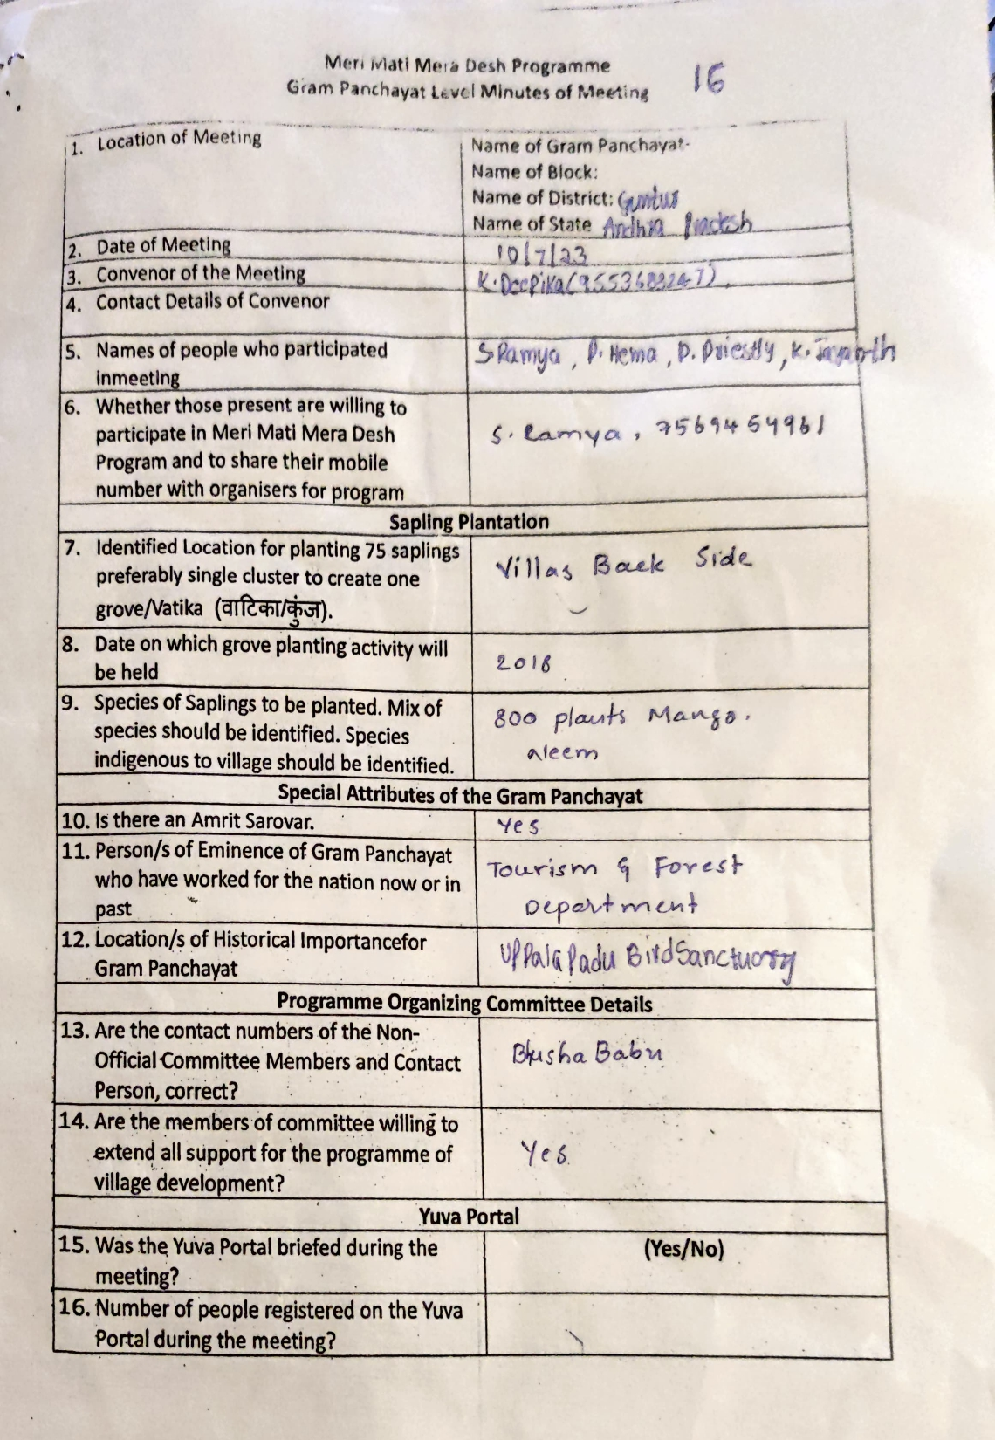

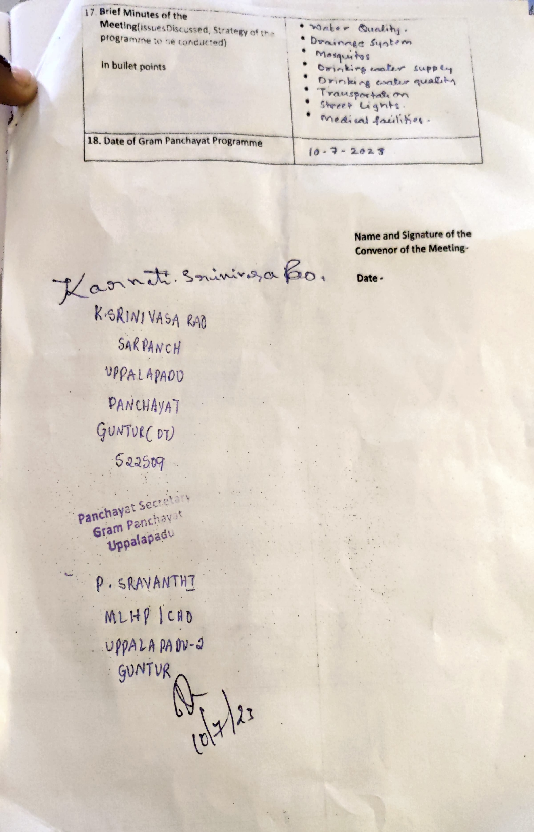

**Acknowledgements**

We take this opportunity to express my deepest gratitude and appreciation to all those people who made this project work easier with words of encouragement, motivation, discipline, and faith by offering different places to look to expand my ideas and helped me towards the successful completion of this project work.

First and foremost, we express my deep gratitude to **Mr. Vasireddy Vidya Sagar**, Chairman, Vasireddy Venkatadri Institute of Technology for providing necessary facilities throughout the B.Tech programme.

We express my sincere thanks to **Dr. Y. Mallikarjuna Reddy**, Principal, Vasireddy Venkatadri Institute of Technology for his constant support and cooperation throughout the B.Tech programme.

We express my sincere gratitude to **Dr. K. Suresh Babu**, Professor & HOD, Computer Science Engineering - Artificial Intelligence and Machine Learning, Vasireddy Venkatadri Institute of Technology for his constant encouragement, motivation and faith by offering different places to look to expand my ideas.

We would like to express my sincere gratefulness to our Guide **Mr. S L V V D Sarma**, Assistant Professor, Computer Science Engineering - Artificial Intelligence and Machine Learning for his insightful advice, motivating suggestions, invaluable guidance, help and support in successful completion of this project.

We would like to express our sincere heartfelt thanks to our Project Coordinator **B .Pardha Saradhi,** Assistant Professor, Computer Science Engineering - Artificial Intelligence and Machine Learning for his valuable advices, motivating suggestions, moral support, help and coordination among us in successful completion of this project.

We would like to take this opportunity to express my thanks to the **Teaching and**

**Non-Teaching** Staff in the Department of Computer Science Engineering - Artificial

Intelligence and Machine Learning,VVIT for their invaluable help and support.

**Name of Student**

PALLEPOGU PRIESTLY



## Department of Computer Science Engineering – Artificial Intelligence and Machine Learning

**CERTIFICATE**

This is to certify that this **Project Report** is the bonafide work of **Mr. Pallepogu Priestly** bearing Reg. No. **20BQ1A4241** respectivelywho had carried out the project entitled **“ Study Sphere - A Holistic Learning Environment "** under our supervision.

|  |  |
| --- | --- |
| **Project Guide** | **Head of the Department** |
| (Mr. S L V V D Sarma, Assistant Professor) | (Dr. K. Suresh Babu, Professor) |

**Submitted for Viva voce Examination held on ____________________________**

**Internal Examiner**

## Contents

**CHAPTER 1:** EXECUTIVE SUMMARY

**CHAPTER 2:** OVERVIEW OF THE COMMUNITY

**CHAPTER 3:** COMMUNITY SERVICE PART

**CHAPTER 4:** OUTCOMES DESCRIPTION

**CHAPTER 5:** RECOMMENDATIONS AND CONCLUSIONS

OF THE MINI PROJECT

**CHAPTER 1**

**EXECUTIVE SUMMARY**

A community service project is an initiative undertaken by individuals or groups to address a specific need or issue within a community. These projects are typically aimed at improving the well-being, quality of life, or circumstances of community members. Community service projects can take various forms and may involve activities such as:

Volunteer Work: Engaging in hands-on activities such as cleaning up parks, serving meals at homeless shelters, tutoring students, or providing companionship to elderly residents.

Fundraising: Organizing events or campaigns to raise funds for local charities, schools, or other community organizations that support important causes.

Awareness Campaigns: Creating and promoting initiatives to raise awareness about social, environmental, or health issues within the community, such as mental health awareness campaigns or recycling drives.

Skill-building Workshops: Offering workshops or training sessions to teach valuable skills to community members, such as financial literacy, job readiness, or computer skills.

Environmental Initiatives: Undertaking projects to protect and improve the environment, such as planting trees, cleaning up litter, or promoting recycling and conservation efforts.

Community Development Projects: Working on projects that aim to enhance the infrastructure or facilities within the community, such as building playgrounds, renovating community centers, or improving access to clean water.

Support Services: Providing support services to vulnerable populations within the community, such as organizing food drives, offering free healthcare clinics, or assisting with disaster relief efforts.

**Community service projects can focus upon the following areas:**

1. Water facilities and drinking water availability
2. Health and hygiene
3. Stress levels and coping mechanisms
4. Health intervention programmes
5. School Education
6. Horticulture
7. Herbal plants
8. Botanical survey
9. Zoological survey
10. Marine products
11. Aqua culture
12. Inland fisheries
13. Animals and species
14. Nutrition
15. Traditional health care methods
16. Food habits
17. Air pollution
18. Water pollution
19. Plantation
20. Soil protection
21. Renewable energy
22. Plant diseases
23. Yoga awareness and practice
24. Health care awareness programmes and their impact
25. Use of chemicals on fruits and vegetables
26. Organic farming
27. Crop rotation
28. Floury culture
29. Access to safe drinking water
30. Geographical survey
31. Geological survey
32. Sericulture
33. Study of species
34. Food adulteration
35. Incidence of Diabetes and other chronic diseases
36. Human genetics
37. Blood groups and blood levels
38. Animal husbandry
39. Mother and child health

**CHAPTER 2**

**OVERVIEW OF THE COMMUNITY**

Uppalapadu, situated in the Guntur district of Andhra Pradesh, India, is a picturesque village located within the Pedakakani mandal of the Guntur revenue division. Positioned at coordinates 16.18°N latitude and 80.30°E longitude, the village is approximately 2 kilometers away from Pedakakani.

One of the notable features of Uppalapadu is its renowned Bird Sanctuary, which serves as a haven for a diverse array of avian species. Situated near the village entrance, the sanctuary's water tanks provide shelter and breeding grounds for numerous birds, including endangered species like spot-billed pelicans and painted storks. These birds migrate from various regions, including Siberia, to nest and thrive in the sanctuary's conducive environment.

In terms of governance, Uppalapadu operates under the jurisdiction of its local selfgovernment, the Uppalapadu gram panchayat. The village is divided into wards, each represented by a ward member, with overall leadership provided by a Sarpanch. Furthermore, as part of the Andhra Pradesh Capital Region, Uppalapadu falls under the administrative purview of the Andhra Pradesh Capital Region Development Authority (APCRDA).

This combination of natural beauty, environmental conservation efforts, and local governance structures underscores Uppalapadu's significance as a vibrant and ecologically rich community within the region.

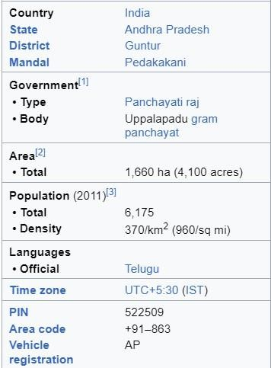

**CHAPTER 3**

**COMMUNITY SERVICE PART**

During the Community Service Project in Uppalapadu, several activities were undertaken to address the issue of plastic pollution and promote sustainable development. These activities included:

Awareness Campaigns and Workshops:

• Conducted educational campaigns to raise awareness about environmental issues such as plastic pollution.

• Organized workshops to teach community members about sustainable practices and waste management techniques.

Community Clean-up Drives:

• Participated in clean-up drives to remove plastic waste from public spaces like parks, streets, and water bodies.

• Collaborated with local authorities and community members to organize and execute clean-up initiatives.

Community Engagement and Surveys:

• Engaged with community members through surveys and interviews to understand their perceptions and behaviors regarding waste management.

• Involved residents in discussions and decision-making processes related to community development projects.

Fundraising Events and Donation Drives:

• Organized fundraising events such as charity drives, bake sales, or community fairs to raise funds for community development projects.

• Collected donations of goods or funds from community members and local businesses to support initiatives aimed at addressing social or environmental issues.

Skills acquired by students:

Leadership Skills:

• Took on leadership roles in organizing and coordinating community service activities. •

Developed skills in delegation, decision-making, and problem-solving.

Communication Skills:

• Communicated effectively with community members, stakeholders, and team members.

• Presented ideas and information clearly during awareness campaigns and workshops.

Teamwork and Collaboration:

• Collaborated with peers, community members, and organizations to plan and execute community service projects.

• Worked together in teams to achieve common goals and objectives.

Reflection on values and learning outcomes:

• Developed a deeper understanding of community needs and challenges.

Cultivated empathy, compassion, and a sense of responsibility towards improving the well-being of others.

• Learned the importance of active citizenship and making meaningful contributions to society.

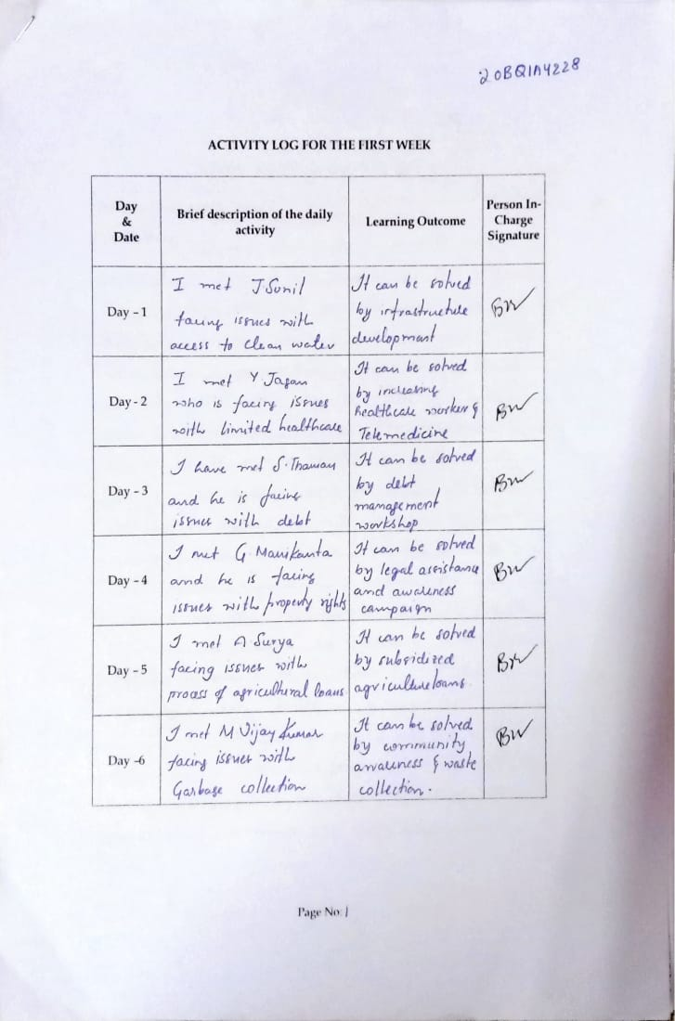

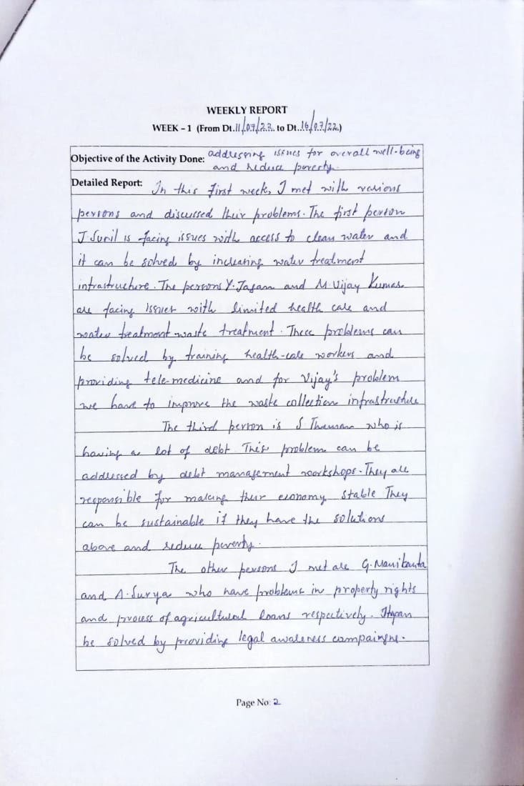

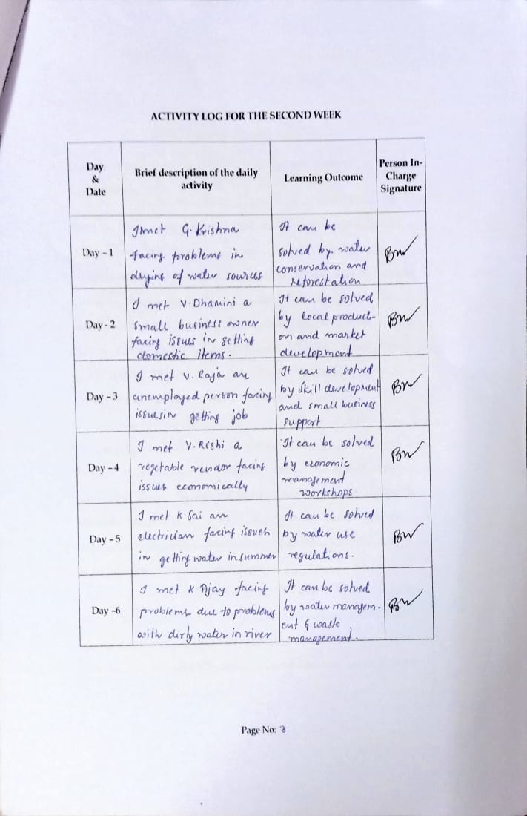

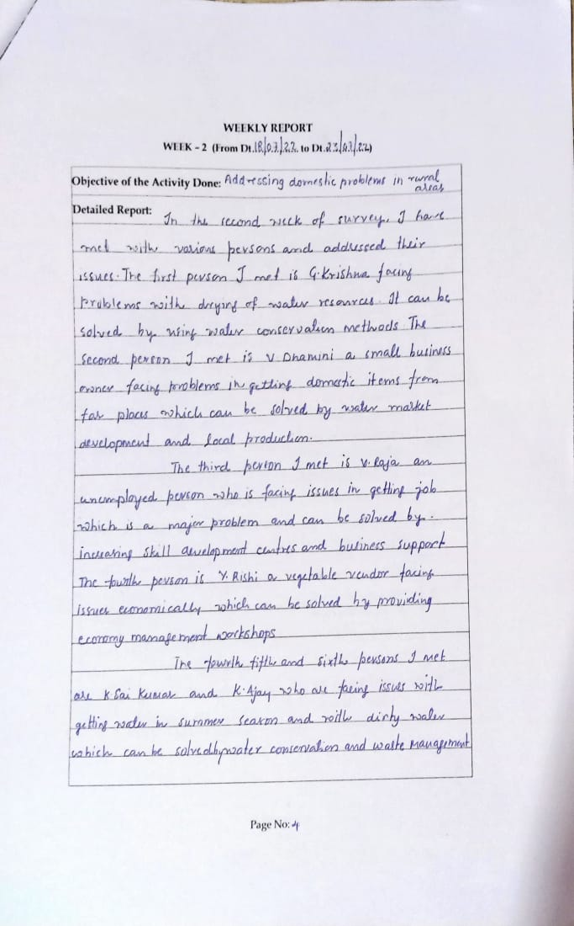

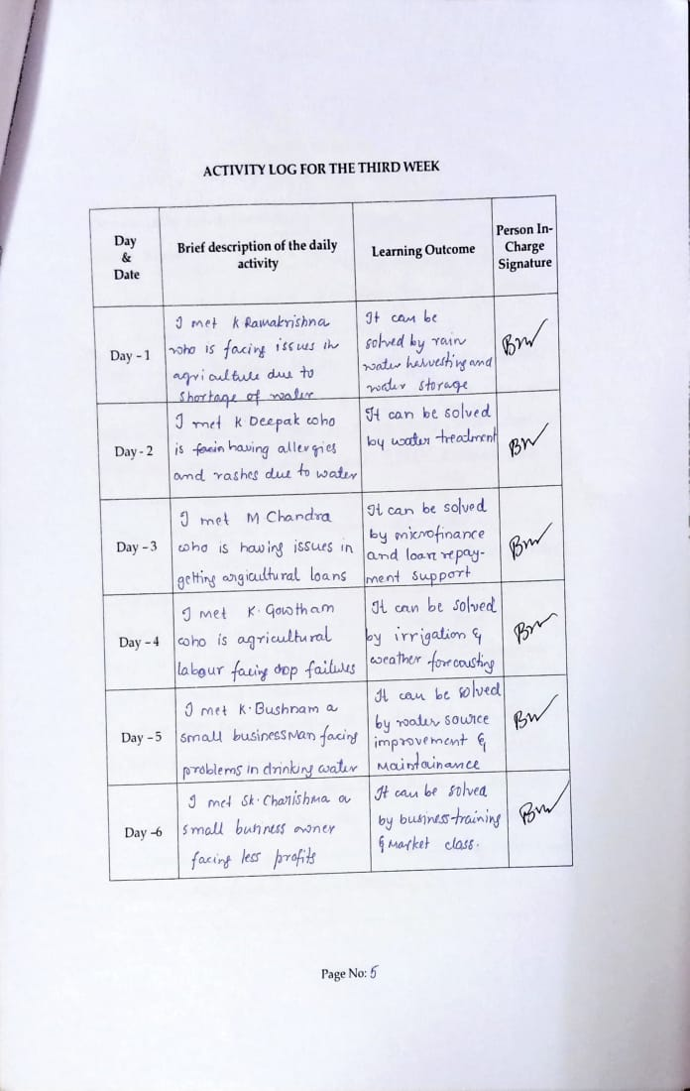

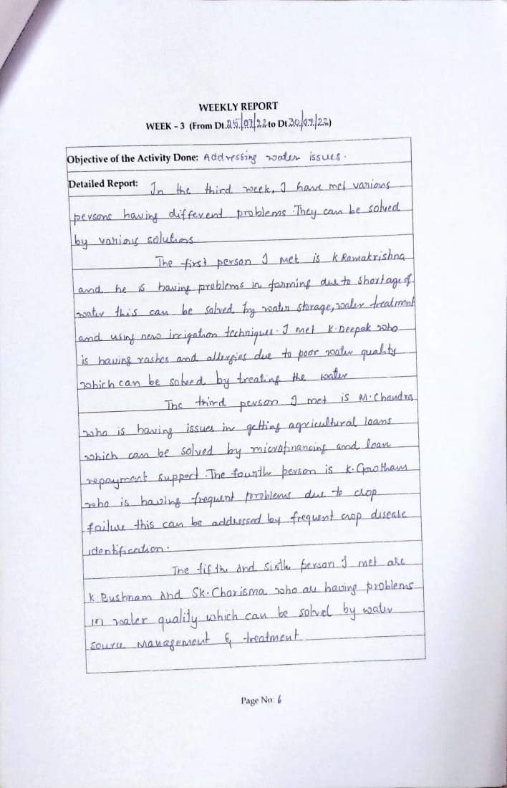

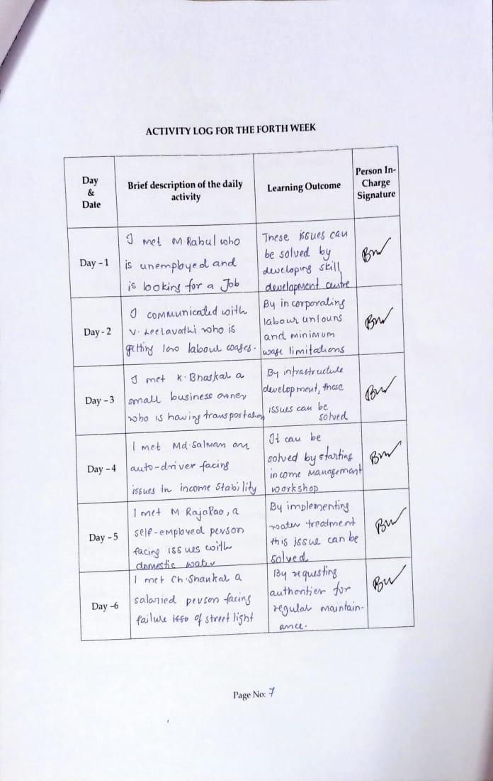

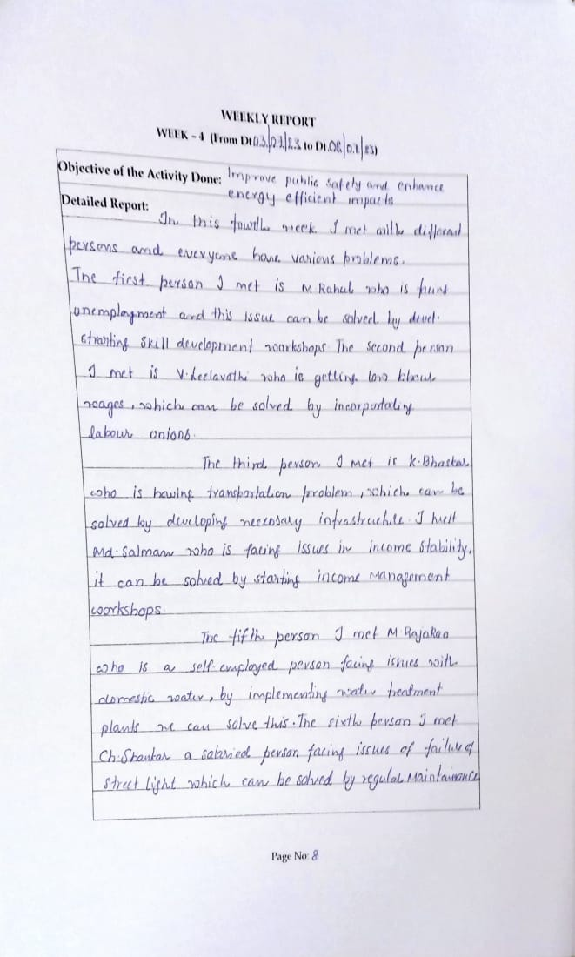

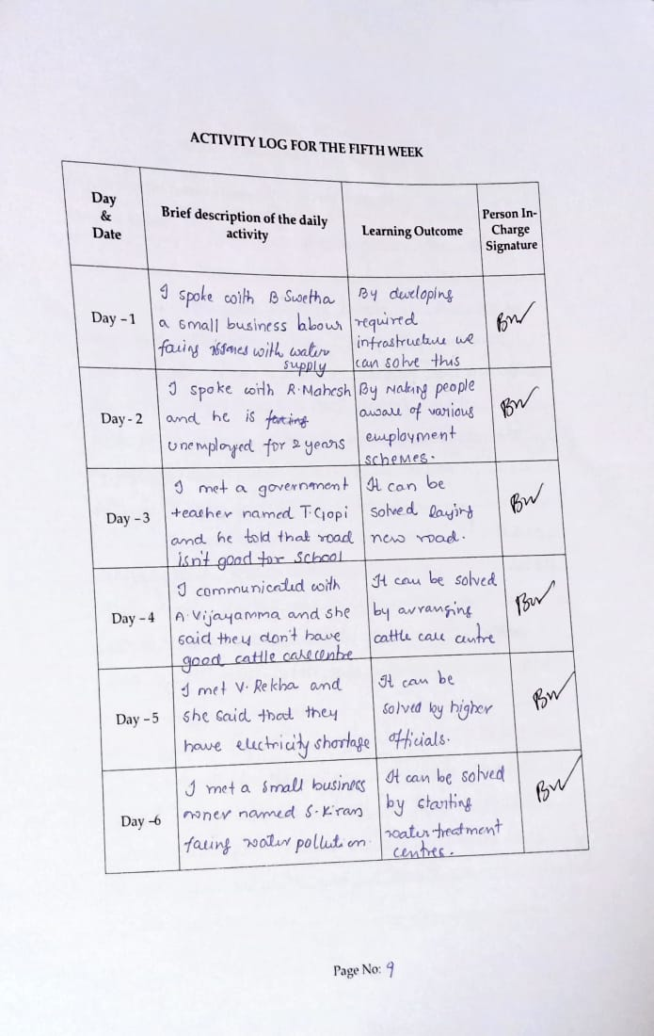

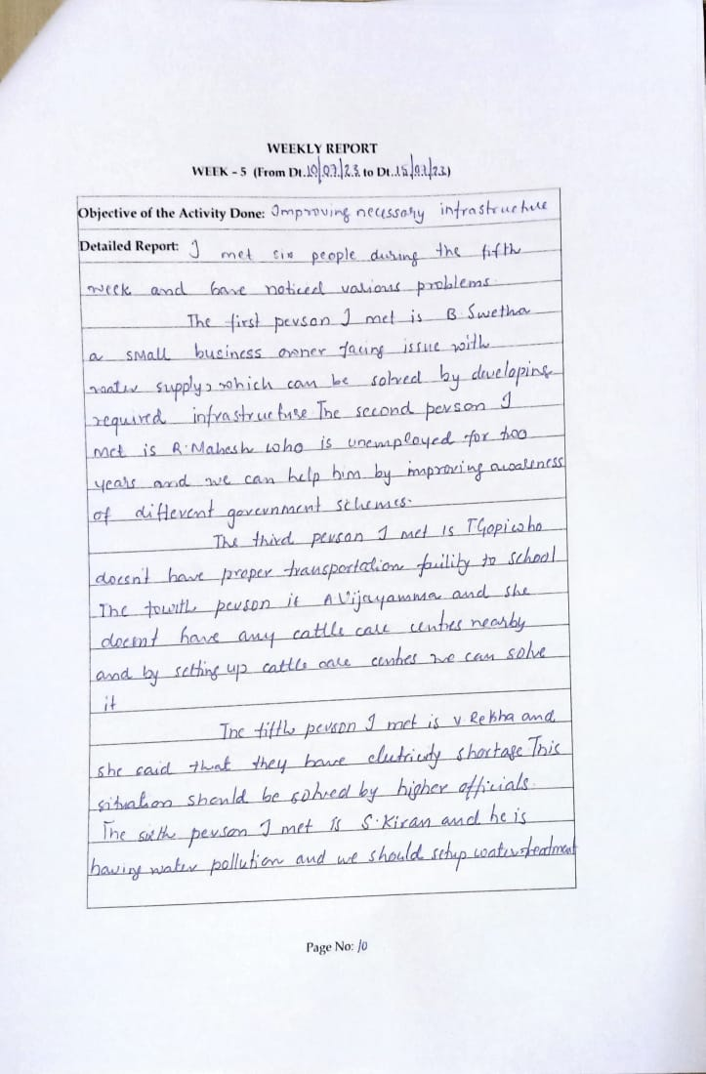

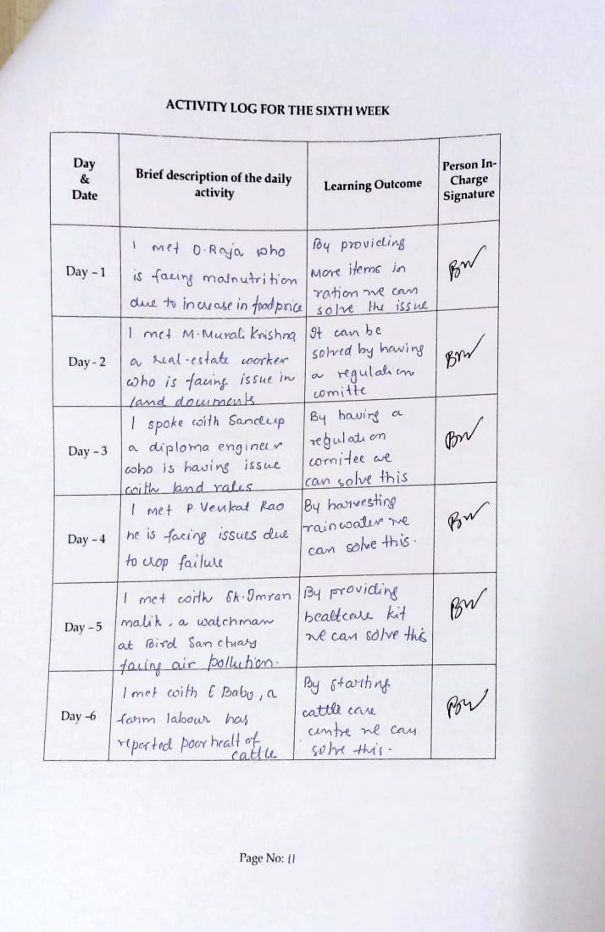

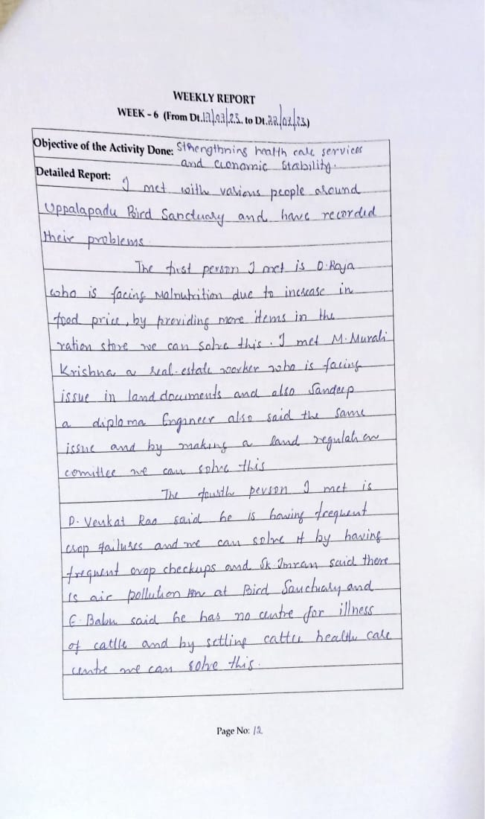

**CHAPTER 4: OUTCOMES DESCRIPTION**

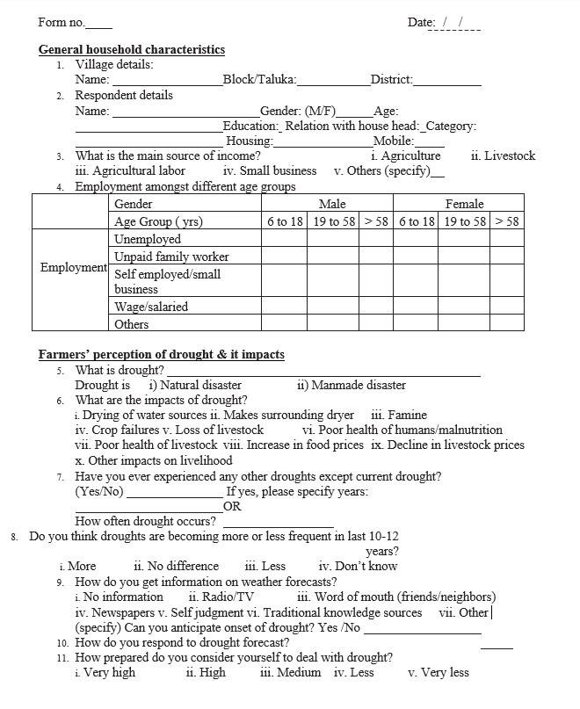

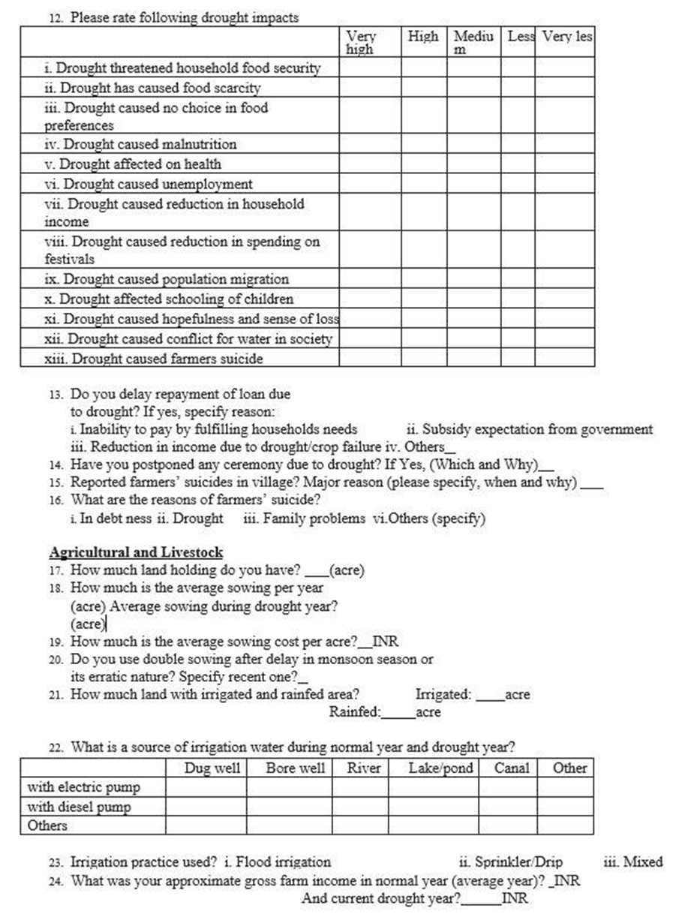

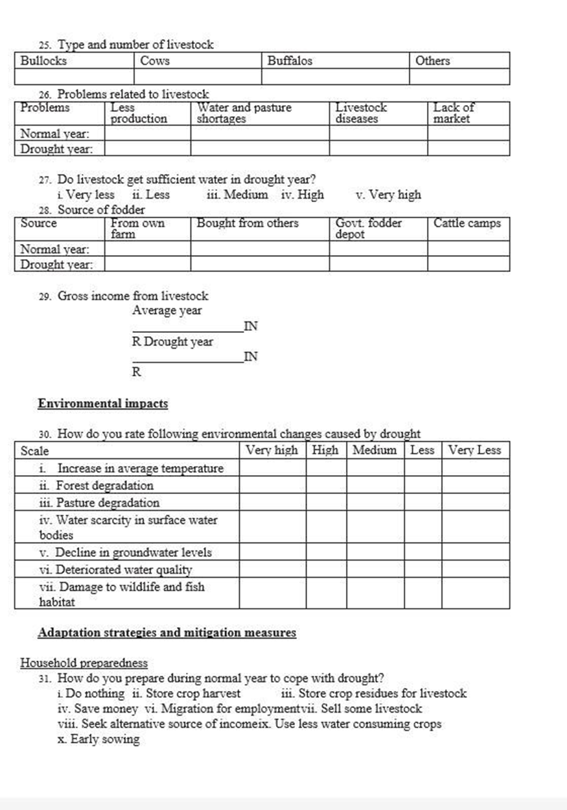

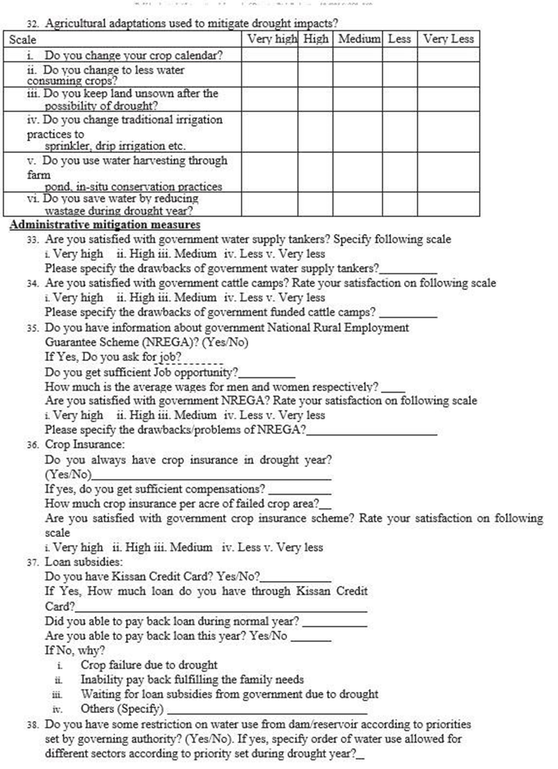

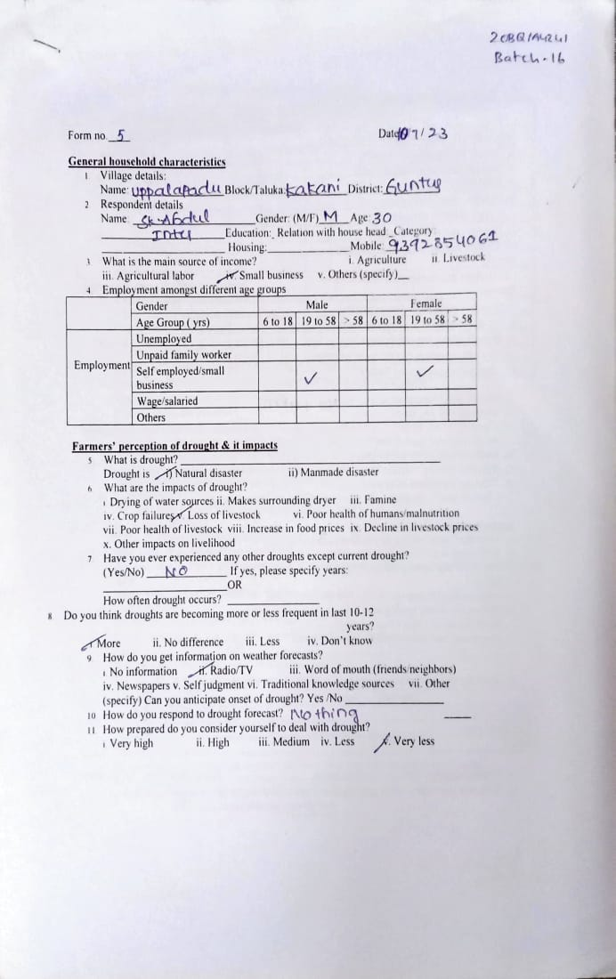

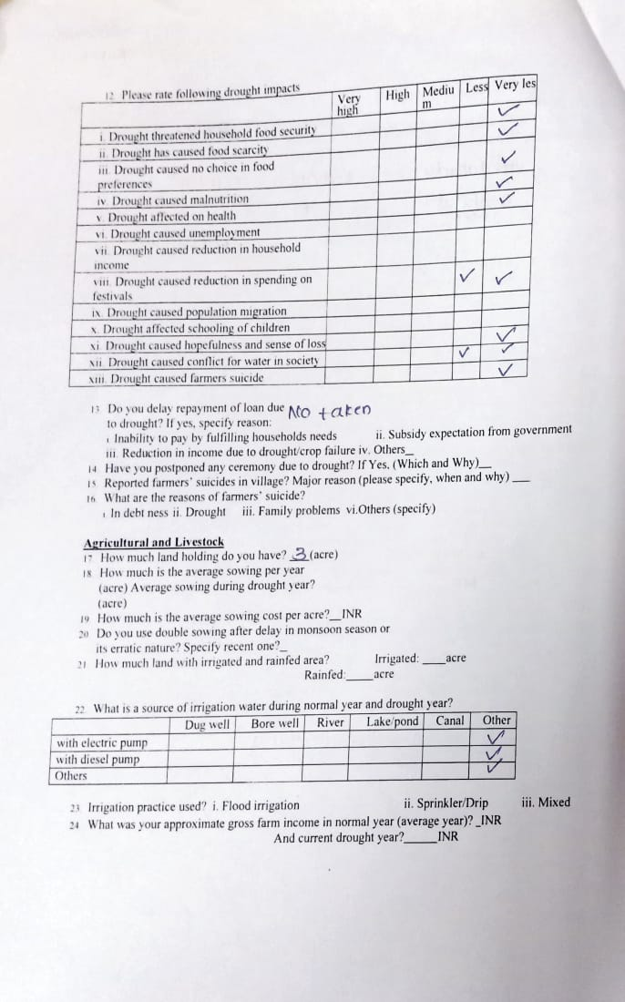

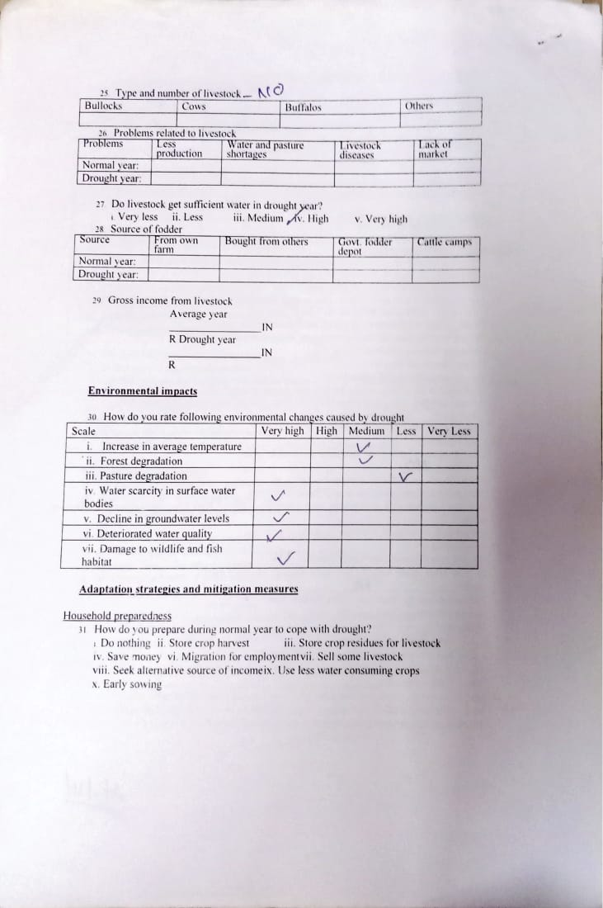

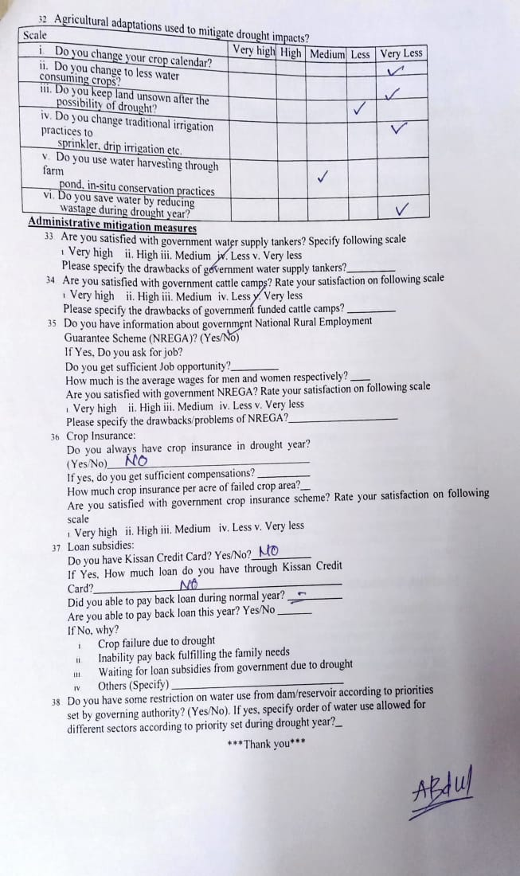

**Problem Identified in the Community:**

In our recent survey conducted in Uppalapadu village, we had observed a problem that there is lack of education to the school students in the. Addressing the issue of student disengagement with education in Uppalapadu village, we recognize the need for a comprehensive solution that leverages technology to enhance learning experiences and promotes teacher effectiveness. To tackle this challenge, we propose the development of an educational application tailored to meet the unique needs of students in the village.

The application will serve as a digital learning platform offering a diverse range of interactive educational resources, including videos, Notes, tutorials, and access through wikipedia. By providing access to quality educational content aligned with the local curriculum, students will have the opportunity to explore subjects at their own pace and in a format that suits their learning preferences. Moreover, the application will be designed to accommodate varying levels of proficiency, ensuring that all students, regardless of their academic background, can benefit from the learning materials.

Central to the success of this initiative is the provision of efficient teacher training programs. Recognizing the pivotal role of teachers in fostering student engagement and learning outcomes, we will implement rigorous training sessions focused on enhancing teaching methodologies and pedagogical techniques. Through these training programs, teachers will be equipped with the necessary skills and strategies to create dynamic and engaging learning environments that inspire curiosity and enthusiasm among students.

The proposed educational application, complemented by comprehensive teacher training initiatives, represents a holistic approach to addressing the challenge of student disengagement with education in Uppalapadu village. By harnessing the power of technology and investing in the professional development of teachers, we aspire to create an educational ecosystem that fosters a love for learning, empowers students to thrive academically, and cultivates a brighter future for the entire community.

**Description of the Community awareness programme/s conducted w.r.t the problems and their outcomes:**

The community awareness program in Uppalapadu village addressed the prevalent issue of student disengagement with education by introducing a tailored web application designed exclusively for student learning. Recognizing the omnipresence of platforms like YouTube and Google for student information-seeking, the program highlighted the importance of providing a dedicated, curated platform specifically catering to educational needs. By leveraging the familiarity and accessibility of digital platforms, the web application aimed to offer a seamless and intuitive learning experience, ensuring that students could easily navigate and access educational resources.

Through interactive sessions and demonstrations, students were introduced to the features and functionalities of the web application, emphasizing its user-friendly interface and diverse range of educational content. Unlike generic search engines, the application was curated to provide relevant, high-quality educational materials aligned with the local curriculum. This personalized approach aimed to enhance student engagement and foster a deeper understanding of academic concepts.

The outcomes of the awareness program were marked by increased student interest and active participation in the learning process. Students expressed enthusiasm for the web application, recognizing its potential to supplement traditional learning methods and expand their knowledge base. By providing a centralized hub for educational resources, the application empowered students to take control of their learning journey, encouraging self-directed exploration and inquiry. Ultimately, the success of the program hinged on its ability to harness the appeal of digital platforms while catering specifically to the educational needs of students, thereby fostering a culture of lifelong learning and academic excellence in Uppalapadu village.

**Outcomes of the School Learning Application :**

1. **Enhanced Student Engagement:**

The application facilitated interactive and engaging learning experiences, leading to increased student interest and participation in academic activities. With access to diverse multimedia resources and interactive lessons, students were motivated to actively explore and learn at their own pace.

**2. Improved Learning Outcomes:**

Through the application's tailored educational content and personalized learning features, students demonstrated improvements in academic performance and comprehension. The interactive nature of the platform allowed for deeper understanding and retention of concepts, resulting in measurable gains in learning outcomes.

**3. Expanded Access to Educational Resources:**

The application provided students with equitable access to high-quality educational materials, overcoming barriers such as geographic limitations and resource constraints. By leveraging technology, students could access educational content anytime, anywhere, bridging gaps in access to educational resources.

**4. Empowered Student Learning**:

The application empowered students to take ownership of their learning journey and develop essential skills such as critical thinking, problem-solving, and digital literacy. By offering a platform for self-directed learning and exploration, students gained confidence and autonomy in their academic pursuits. Report of the mini-project work done in the related subject w.r.t the habitation/village.

**5. Holistic Pedagogical Approach:**

Teacher training programs focused on adopting a holistic approach to education, emphasizing the importance of nurturing students' intellectual, emotional, and social development. Teachers were trained in methodologies that promote active learning, inquiry-based instruction, and differentiated instruction, catering to the diverse needs and learning styles of students. Additionally, training modules incorporated strategies for fostering positive teacher-student relationships and creating inclusive learning environments conducive to optimal learning outcome.

***Project Statement*** :

In Uppalapadu village, the shortage of teaching staff and educational resources at the primary school impedes students' learning and future prospects. To address this, implementing online education platforms offers a viable solution, granting students access to a wider array of educational materials despite resource constraints. These platforms enable interactive learning experiences and virtual classrooms, enriching students' education. Additionally, investing in offline teacher training programs enhances pedagogical methods, ensuring educators are equipped to deliver effective instruction in traditional classroom settings, ultimately improving educational outcomes in the community.

***Why it was selected :***

Emphasizing the shortage of teaching staff and resources in Uppalapadu village's primary school is critical due to its potential ramifications for the community. With students lacking proficiency in literacy and numeracy, these deficits compound over time, becoming increasingly difficult to address. Without prompt interventions like hiring more staff, upgrading infrastructure, and providing learning materials, Uppalapadu's youth may face academic struggles in higher grades, limiting their career prospects and hindering the village's progress. Given education's pivotal role in societal and economic advancement, improving schooling conditions is essential for Uppalapadu's long-term prosperity.

**Consequences of Illiteration in the villages :**

**1. Academic Struggles:**

The shortage of teaching staff and resources impedes students' learning progress, leading to challenges in grasping basic concepts and poor academic performance, which may hinder their future educational opportunities and prospects.

**2. Limited Career Opportunities:**

Inadequate education hampers students' future prospects, limiting their ability to pursue higher education or secure employment, perpetuating cycles of poverty and unemployment and hindering the village's economic growth.

**3. Reduced Economic Development:**

A poorly educated workforce stifles economic growth, deterring businesses from investing in the village and hindering job creation and entrepreneurship, thus limiting the village's overall prosperity and potential for development.

**4. Social Disparities:**

Educational disparities deepen social divides, disproportionately affecting marginalized students and exacerbating inequality within the community, leading to social tensions and hindering efforts to achieve social cohesion and inclusivity.

**5. Decreased Community Well-being:**

Inadequate education contributes to higher rates of unemployment, poverty, and health issues, diminishing overall quality of life and hindering community development efforts, thus impeding the village's progress and well-being.

**6. Hindered Village Advancement:**

The inability to address educational shortcomings hampers the village's progress, limiting its competitiveness and ability to capitalize on opportunities for economic and social development, ultimately hindering its advancement and potential for future growth.

These shortcomings exacerbate social disparities and decrease community well-being, ultimately hindering the village's overall advancement and potential for future growth. Addressing these issues is crucial for improving educational outcomes, fostering economic prosperity, and enhancing the well-being of Uppalapadu's residents.

**Features of the Application :**

1. **User Registration and Login :**

Allows users to create personalized accounts, enabling them to access tailored features and save preferences. Ensures data security by implementing secure login procedures, safeguarding user information and privacy.

1. **YouTube Video Search:**

Enables users to search and watch YouTube videos directly within the application, streamlining multimedia content consumption. Enhances user engagement by integrating multimedia resources without requiring users to switch to external platforms**.**

1. **Homework Assistance:**

Offers tools and resources to support students in completing assignments effectively, promoting academic success. Facilitates learning by providing access to study guides, tutorials, and educational materials tailored to specific subjects.

1. **Wikipedia Integration:**

Provides quick access to Wikipedia articles within the application, offering reliable information for research purposes. Enhances user convenience by eliminating the need to switch between multiple platforms for gathering information.

1. **Dictionary Lookup:**

Offers a built-in dictionary feature for instant word definitions and language comprehension. Supports users in improving vocabulary and language skills by providing easy access to word meanings and synonyms.

1. **Browse Books:**

Grants users access to a diverse catalog of books within the application, fostering reading habits and exploration. Enhances reading experience by offering a convenient platform for discovering and accessing literary works.

1. **Unit Conversion:**

Simplifies measurement conversions by providing tools to convert between different units and systems. Facilitates tasks such as converting lengths, weights, volumes, and temperatures, aiding users in various fields and contexts.

**Frontend Development using HTML/CSS :**

* **Semantic HTML:** Utilize semantic HTML elements to provide a clear structure and meaning to the content of your web pages. This not only improves accessibility and SEO but also makes your code more maintainable.
* **Responsive Design with CSS:** Implement responsive design techniques using CSS to ensure that your web application displays appropriately across various devices and screen sizes. This involves using media queries, flexible layouts, and fluid grids to adapt the layout and styling based on the device viewport.

**Backend Development using Django :**

* **Model-View-Template (MVT) Architecture:** Django follows the Model-View-Template architecture, which provides a clear separation of concerns. Models represent the data structure, Views handle the business logic, and Templates manage the presentation layer. This architectural pattern promotes code organization and maintainability.
* **Django ORM:** Django provides an Object-Relational Mapping (ORM) layer that abstracts database interactions. Instead of writing SQL queries directly, you can define Python classes (models) that map to database tables, and Django's ORM handles database operations using Python methods. This simplifies database access and reduces the likelihood of SQL injection vulnerabilities.

**Database Management using PostgreSQL:**

* **Relational Database Management System:** PostgreSQL is a powerful open-source relational database management system (RDBMS) known for its reliability, robustness, and adherence to SQL standards. Utilize its features such as transactions, constraints, and triggers to ensure data integrity and consistency.
* **Scalability and Performance:** PostgreSQL offers scalability features like replication, partitioning, and indexing, which allow you to efficiently manage large volumes of data and handle increased workload demands. Optimize database performance by tuning configurations and utilizing appropriate indexing strategies.

***Technology/ Software Used:***

**Software Requirements:**

1.Frontend Development:

• HTML

• CSS

• Javascript

• Boostrap (for responsive design)

2. Backend Development:

• XAMPP (includes Apache server and MySQL database)

3. Version Control System:

• Git

• Github

4.User Interface Design Tool:

• Figma (for designing website layouts and components)

5.Cloud Hosting Platform:

• Azure (for deploying the website)

**Hardware Requirements:**

1.Operating System:

* Windows 10 or Windows 11

2.RAM:

* 4 GB or more

3.Storage:

* Sufficient storage for project files, typically 256 GB SSD or larger

***Output Screens/Screenshots:***

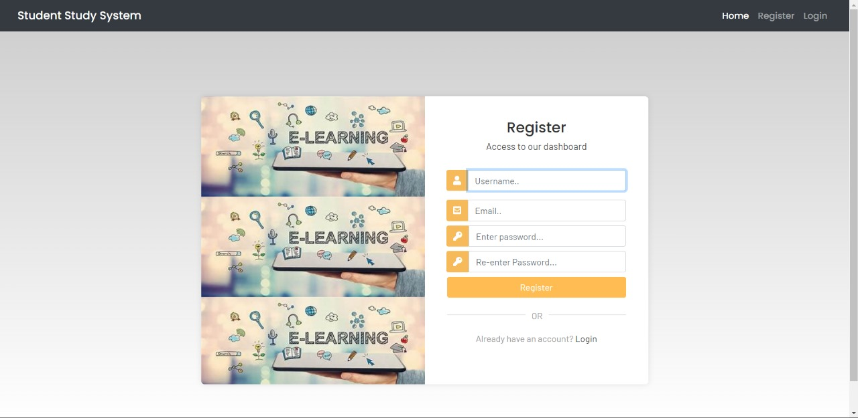

***Fig 4.1 Registration Page***

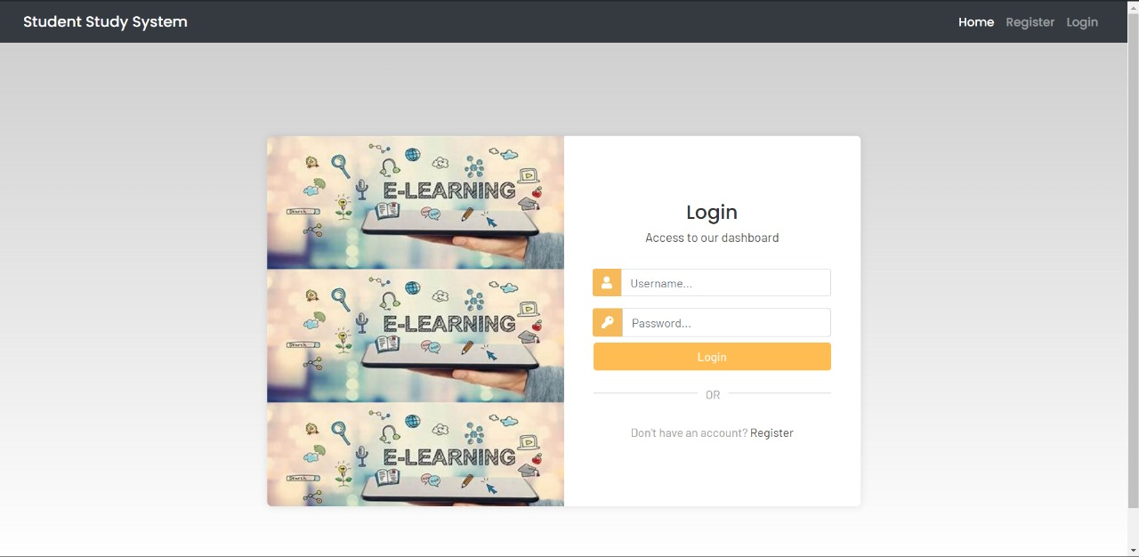

***Fig 4.2 Login Page***



***Fig 4.3 User Dashboard***

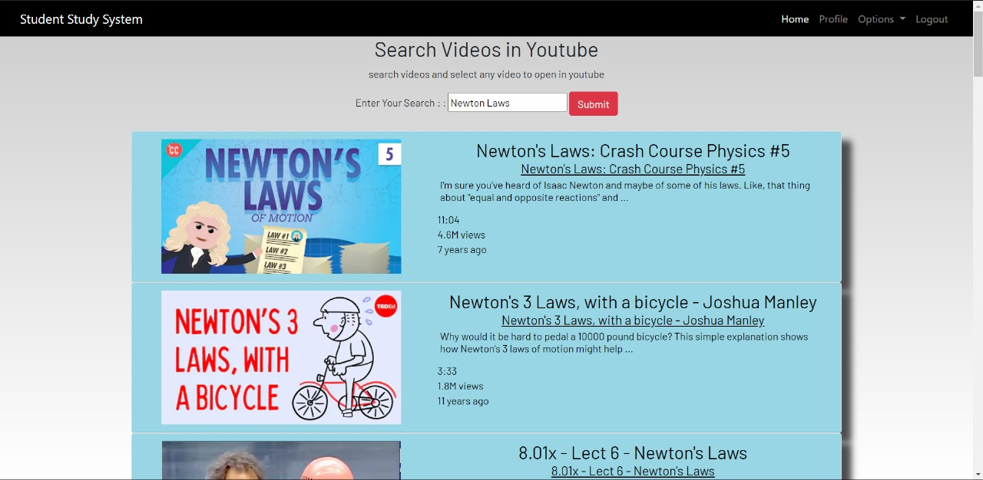

***Fig 4.4 Youtube Search***

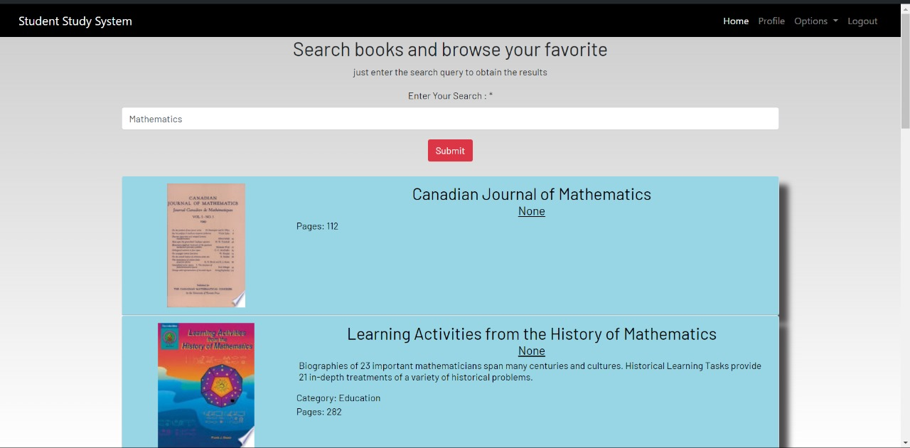

***Fig 4.5 Search for books***

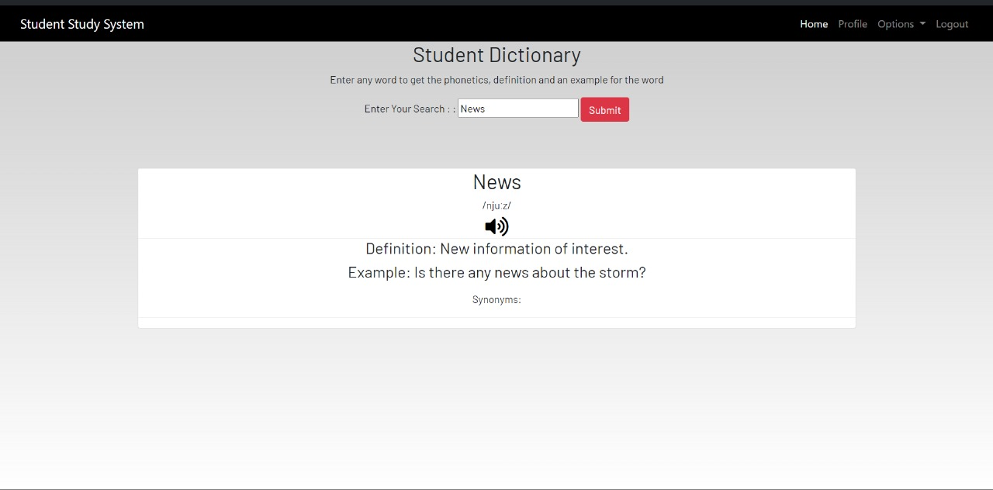

***Fig 4.6 Dictionary***

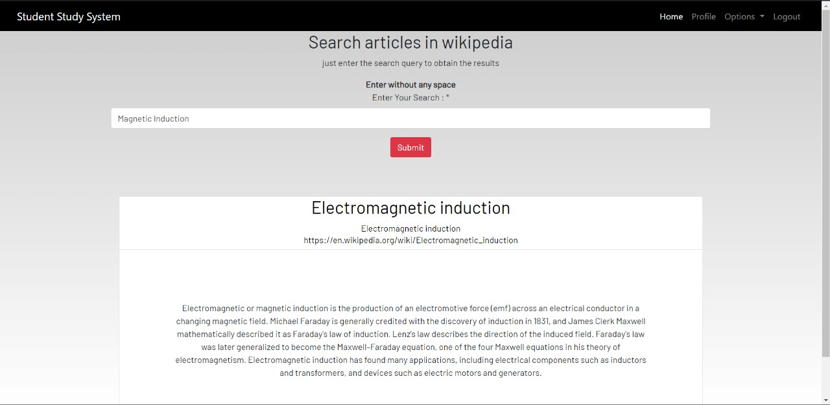

***Fig 4.7 Wikipedia Search***

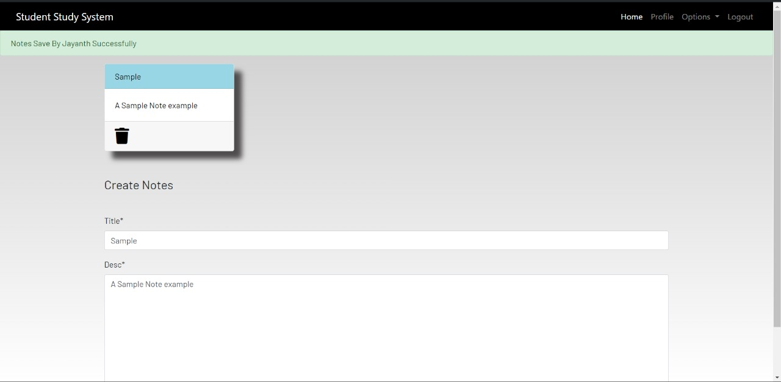

***Fig 4.8 Create Notes***

***Overall Conclusion :***

The proposed project is a comprehensive web application designed to cater to a wide range of user needs and interests, spanning from educational support to multimedia consumption and practical utilities. By integrating features such as user registration and login procedures, the application ensures personalized experiences while maintaining robust data security measures, prioritizing the protection of user information and privacy. This foundational aspect establishes a secure environment for users to access tailored features, fostering trust and confidence in the platform.

Furthermore, the inclusion of functionalities like YouTube video search, Wikipedia integration, and homework assistance streamlines users' access to multimedia content and educational resources within a single interface. This consolidation not only enhances user convenience by eliminating the need to navigate across multiple platforms but also promotes engagement by offering diverse and relevant content directly within the application. Whether users seek academic support, research materials, or entertainment, the application serves as a comprehensive hub, catering to various interests and requirements.

Moreover, the project's emphasis on practical utilities such as dictionary lookup, book browsing, and unit conversion adds tangible value to users' daily activities and tasks. By providing instant access to word definitions, educational materials, literary works, and conversion tools, the application facilitates efficiency and productivity across diverse contexts. Overall, this multifaceted approach positions the project as a versatile and indispensable tool for users seeking educational support, information access, and practical assistance, enriching their online experience and empowering them in their endeavors.

**CHAPTER 5**

**RECOMMENDATIONS AND CONCLUSIONS OF THE MINI**

**PROJECT**

In conclusion, the mini-project demonstrates the potential to create a multifaceted web application that addresses diverse user needs and interests, from educational support to multimedia consumption and practical utilities. By implementing robust data security measures, consolidating relevant content and resources, and prioritizing user feedback and inclusivity, the project can offer a valuable and engaging online platform for users.

1. **Enhanced Personalization Features:**

* Implement personalized recommendations and user profiles to tailor the application experience based on individual preferences and behavior.
* By leveraging machine learning algorithms or user-based preferences, the application can provide targeted content suggestions, recommendations, and customized learning paths, enhancing user engagement and satisfaction.

1. **Mobile Responsiveness and Cross-Platform Compatibility:**

* Optimize the application for mobile responsiveness and ensure cross-platform compatibility across various devices and browsers.
* This includes adopting responsive design principles, optimizing performance for mobile networks, and conducting thorough testing to guarantee a seamless user experience across different platforms, ultimately expanding the reach and accessibility of the application.

1. **Community Engagement and User Forums:** 
   * Foster a sense of community and collaboration by incorporating user forums, discussion boards, or social features within the application.
   * Encouraging users to interact, share knowledge, and support each other creates a vibrant ecosystem and enriches the user experience through peer learning, networking opportunities, and collective problem-solving.
2. **Gamification Elements for Learning:**

* Introduce gamification elements such as badges, achievements, progress tracking, and leaderboards to incentivize user engagement and motivate learning.

1. **Continuous Performance Monitoring and Optimization:**

* Implement robust monitoring tools and analytics to track application performance, user interactions, and engagement metrics continuously.

1. **Collaboration with Educational Institutions and Experts:**

* Forge partnerships with educational institutions, subject matter experts, and content creators to enrich the application's content offerings and credibility.
* Collaborating with renowned educators, authors, or institutions can provide access to high-quality educational materials, expertise, and endorsements, enhancing the application's reputation, trustworthiness, and educational value.

In conclusion, the project delivers a cohesive and user-friendly web application that effectively integrates various features to meet diverse user needs. By prioritizing security, content accessibility, and engagement, it provides a valuable platform for learning, multimedia consumption, and productivity. Moving forward, ongoing refinement and responsiveness to user feedback will ensure its continued success and relevance in the online environment.

### Student Self-Evaluation for the Community Service Project

**Student Name:** PALLEPOGU PRIESTLY

**Registration No:** 20BQ1A4241

**Period of CSP:** 8 WEEKS **From:** 01-07-2023  **To:** 31-08-2023

**Date of Valuation:**  26-03-2-24

**Please rate your performance in the following areas:**

#### Rating Scale: Letter grade of CGPA calculation to be provided

|  |  |  |  |  |  |
| --- | --- | --- | --- | --- | --- |
| 1 Oral communication | 1 | 2 | 3 | 4 | 5 |
| 2 Written communication | 1 | 2 | 3 | 4 | 5 |
| 3 Proactiveness | 1 | 2 | 3 | 4 | 5 |
| 4 Interaction ability with community | 1 | 2 | 3 | 4 | 5 |
| 5 Positive Attitude | 1 | 2 | 3 | 4 | 5 |
| 6 Self-confidence | 1 | 2 | 3 | 4 | 5 |
| 7 Ability to learn | 1 | 2 | 3 | 4 | 5 |
| 8 Work Plan and organization | 1 | 2 | 3 | 4 | 5 |
| 9 Professionalism | 1 | 2 | 3 | 4 | 5 |
| 10 Creativity | 1 | 2 | 3 | 4 | 5 |
| 11 Quality of work done | 1 | 2 | 3 | 4 | 5 |
| 12 Time Management | 1 | 2 | 3 | 4 | 5 |
| 13 Understanding the Community | 1 | 2 | 3 | 4 | 5 |
| 14 Achievement of Desired Outcomes | 1 | 2 | 3 | 4 | 5 |
| **15 OVERALL PERFORMANCE** | **1** | **2** | **3** | **4** | **5** |

**Date: Signature of the Student**

**PHOTOS & VIDEO LINKS**

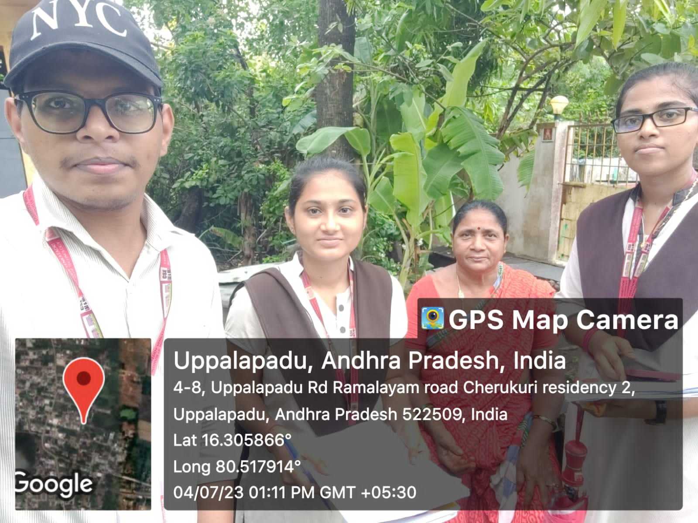

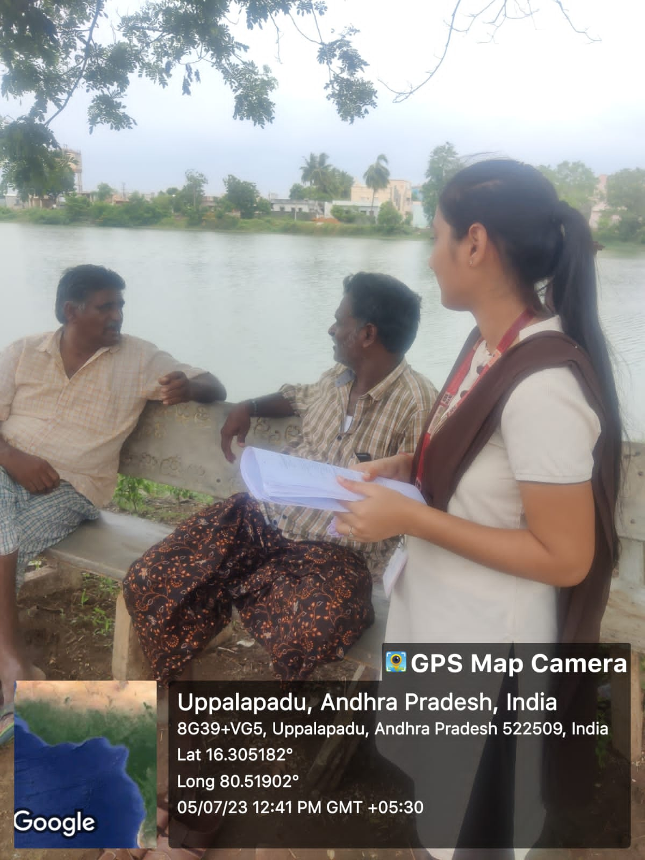

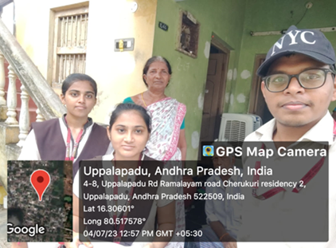

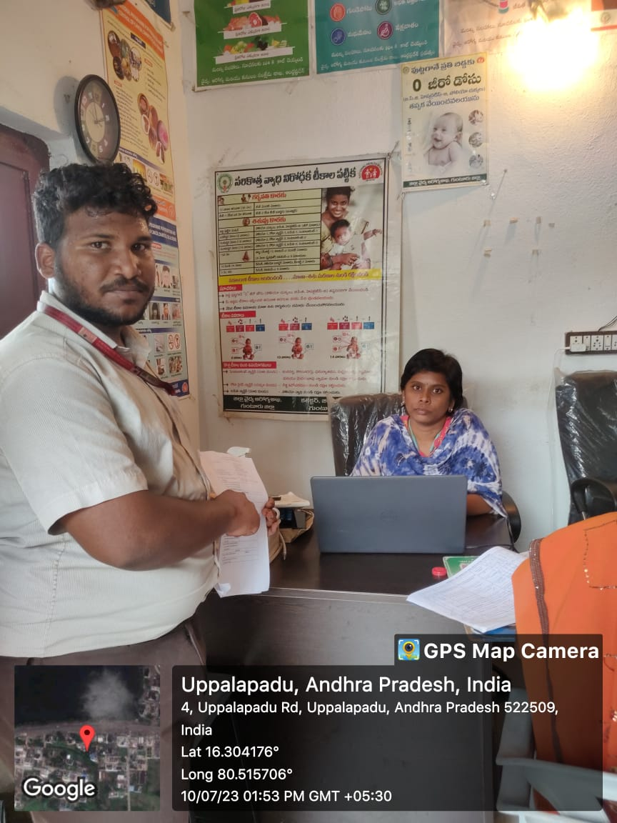

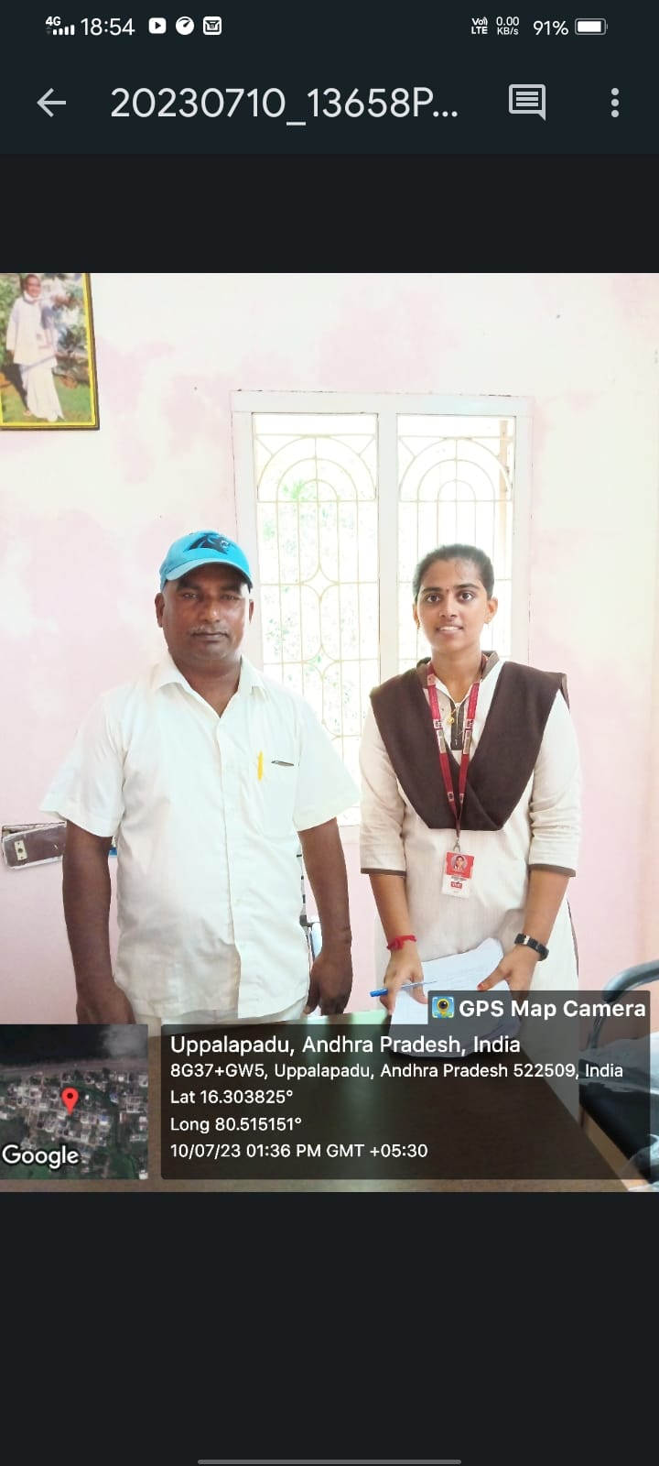

Google Drive Link:

https://drive.google.com/drive/folders/1USfx_tpX7VJOgHm-QrSEbQp94pb6B40d

**INTERNAL ASSESSMENT STATEMENT**

**Name Of the Student:**  PALLEPOGU PRIESTLY

**Programme of Study:**  Bachelor of Technology

**Year of Study:**  IV-II

**Branch:**  COMPUTER SCIENCE ENGINEERING - ARTIFICIAL INTELLIGENCE & MACHINE LEARNING

**Register No/H.T. No:** 20BQ1A4241

**Name of the College:** Vasireddy Venkatadri Institute of Technology

**University:** Jawaharlal Nehru Technological University Kakinada (JNTUK)

|  |  |  |  |
| --- | --- | --- | --- |
| ***Sl.No*** | ***Evaluation Criterion*** | ***Maximum***  ***Marks*** | ***Marks Awarded*** |
| 1. | Activity Log | 20 |  |
| 2. | Community Service Project Implementation | 30 |  |
| 3. | Mini Project Work | 25 |  |
| 4. | Oral Presentation | 25 |  |
|  | GRAND TOTAL | 100 |  |

|  |  |  |
| --- | --- | --- |
| **Date:**    **Certified by** |  | **Signature of the Faculty Guide** |
| **Date:** |  | **Signature of the Head of the Department/Principal** |

#### Seal